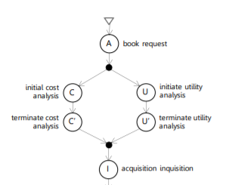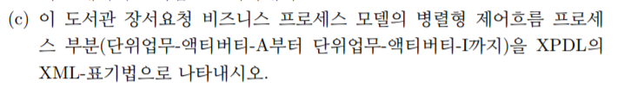
- A
<Activitys>
<Activity Id=“Activity001” Name=”book request”>
<Activity>
<Activitys>
- Transition001
<Transition>
<Transitions>
<Transition Id=”Transition001 From=”Activity001” To=”Activity002” Name=”Start_To_AND_Split”>
</Transition>
</Transitions>

- AND
<Activitys>
<Activity Id=”Activity002” Name=”AND_SPLIT”>
<Route GatewayType=”AND” />
<TransitionRestrictions>
<TransitionRestriction>
<Split Type=”AND”>
<TransitionRefs>
<TransitionRef Id=”Transition002 />
<TransitionRef Id=”Transition006 />
</TransitionRefs>
</Split>
</TransitiononRestriction>
</TranstionRestrictions>
</Activity>
</Activitys>
- Transition002
<Transition>
<Transitions>
<Transition Id=”Transition002 From=”Activity002” To=”Activity003” Name=”Start_To_Initial cost analysis”>
</Transition>
</Transitions>
- C
<Activitys>
<Activity Id=“Activity003” Name=”initial cost analysis”>
<Activity>
<Activitys>
- Transition003
<Transitions>
<Transition Id=”Transition003 From=”Activity003” To=”Activity004” Name=”Start_To_terminate cost analysis”>
</Transition>
</Transitions>
- C’
<Activitys>
<Activity Id=“Activity004” Name=”terminate cost analysis”>
<Activity>
<Activitys>
- Transition004
<Transitions>
<Transition Id=”Transition004 From=”Activity004” To=”Activity003” Name=”Start_To_AND_JOIN”>
</Transition>
</Transitions>
- AND
<Activitys>
<Activity Id=”Activity005” Name=”AND_JOIN”>
<Route GatewayType=”AND” />
<TransitionRestrictions>
<TransitionRestriction>
<Split Type=”AND”>
<TransitionRefs>
<TransitionRef Id=”Transition005 />
</TransitionRefs>
</Split>
</TransitiononRestriction>
</TranstionRestrictions>
</Activity>
</Activitys>
- Transition006
<Transitions>
<Transition Id=”Transition006 From=”Activity002” To=”Activity007” Name=”Start_To_initiate utility analysis”>
</Transition>
</Transitions>
- U
<Activitys>
<Activity Id=“Activity006” Name=”initial utility analysis”>
<Activity>
<Activitys>
- Transition007
<Transitions>
<Transition Id=”Transition007 From=”Activity006” To=”Activity007” Name=”Start_To_terminate utility analysis”>
</Transition>
</Transitions>
- U’
<Activitys>
<Activity Id=“Activity007” Name=”terminate utility analysis”>
<Activity>
<Activitys>
- Transition008
<Transitions>
<Transition Id=”Transition008 From=”Activity007” To=”Activity005” Name=”Start_to_AND_JOIN”>
</Transition>
</Transitions>
- Transition009
<Transitions>
<Transition Id=”Transition009 From=”Activity005” To=”Activity008” Name=”Start_to_acquisition inquisition”>
</Transition>
</Transitions>
- I
<Activitys>
<Activity Id=“Activity008” Name=”acquisition inquisition”>
<Activity>
<Activitys>

(d)
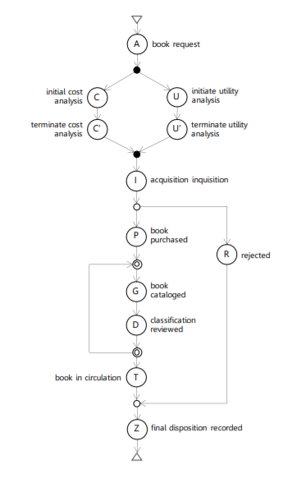
STEP | SET OF ACTIVITIES | SELECTED ACT | USED BB | NEW ACT
1 | A | A | SEQUENTIAL | I
2 | AI | A | SEQUENTIAL | C
3 | ACI | C | AND | U
4 | ACUI | C | SEQUENTIAL | C’
5 | ACC’UI | U | SEQUENTIAL | U’
6 | ACC’UU’I | I | SEQUENTIAL | P
7 | ACC’UU’IP | P | OR-SPLIT | R
8 | ACC’UU’IPR | PR | OR-JOIN | Z
9 | ACC’UU’IPRZ | P | SEQUENTIAL | T
10 | ACC’UU’IPTRZ | P | SEQUENTIAL | G
11 | ACC’UU’IPGTRZ | G | DO-WHILE | D
12 | ACC’UU’IPGDTRZ | T | SEQUENTIAL
13 | ACC’UU’IPGDTRZ

